EXP.NO: 2 | Write JavaScript Programme to validate the following fields of the HTML Registration page.
DATE: 06/02/2025

AIM:
To write JavaScript code to validate user input in a registration form. The validation will ensure that the data entered by the user meets specific criteria for each field. This will help in maintaining data integrity and prevent invalid submissions.
ALGORITHM:
1. Input:
- The user fills in the following fields: First Name, Password, E-mail, Mobile Number, Last Name, and Address.
2. Validation Steps:
- Validate First Name:
  - Check if the first name contains only alphabets.
  - Ensure the length of the First Name is at least 6 characters.
  - If any of these conditions fail, display an error message indicating the required input.
- Validate Password:
  - Check if the password is at least 6 characters long.
  - If it is less than 6 characters, display an error message.
- Validate E-mail:
  - Use a regular expression to check if the email follows the standard pattern: name@domain.com.
  - Ensure that the email contains no invalid characters and matches the required pattern.
  - If it doesn't match, display an error message indicating an invalid email format.
- Validate Mobile Number:
  - Check if the mobile number contains exactly 10 digits.
  - Ensure there are no alphabets or special characters.
  - If the number is invalid, display an error message indicating the correct format.
- Validate Last Name:
  - Ensure the Last Name field is not empty.
  - If it is empty, display an error message.
- Validate Address:
  - Ensure the Address field is not empty.
  - If it is empty, display an error message.
Code:
<!DOCTYPE html>
<html lang="en">
<head>
<meta charset="UTF-8">
<title>Login</title>
<style>
body {
margin: 0;
padding: 0;
font-family: Arial, sans-serif;
background: linear-gradient(to right, #4e73df, #1cc88a);
display: flex;
justify-content: center;
align-items: center;
height: 100vh;
}

.login-container {
background: white;
padding: 40px;
border-radius: 10px;
box-shadow: 0 10px 25px rgba(0,0,0,0.2);
width: 400px;
text-align: center;
}

.login-container h2 {
margin-bottom: 20px;
color: #333;
}

.input-box {
margin-bottom: 15px;
text-align: left;
}

.input-box label {
font-weight: bold;
}

.input-box input, .input-box textarea {
width: 100%;
padding: 8px;
margin-top: 5px;
border-radius: 5px;
border: 1px solid #ccc;
}

.btn {
width: 100%;
padding: 10px;
background: #4e73df;
color: white;
border: none;
border-radius: 5px;
cursor: pointer;
font-size: 16px;
}

.btn:hover {
background: #2e59d9;
}

#message {
margin-top: 15px;
font-weight: bold;
}
</style>
</head>
<body>

<div class="login-container">
<h2>Login</h2>

<div class="input-box">
<label>First Name</label>
<input type="text" id="firstname" placeholder="Enter First Name">
</div>

<div class="input-box">
<label>Last Name</label>
<input type="text" id="lastname" placeholder="Enter Last Name">
</div>

<div class="input-box">
<label>Address</label>
<textarea id="address" placeholder="Enter Address"></textarea>
</div>

<div class="input-box">
<label>Email</label>
<input type="text" id="email" placeholder="Enter Email">
</div>

<div class="input-box">
<label>Password</label>
<input type="password" id="password" placeholder="Enter Password">
</div>

<div class="input-box">
<label>Mobile Number</label>
<input type="text" id="mobile" placeholder="Enter 10-digit Mobile Number">
</div>

<button class="btn" onclick="validateForm()">Submit</button>

<p id="message"></p>
</div>

<script>
function validateForm() {

var fname = document.getElementById("firstname").value.trim();
var lname = document.getElementById("lastname").value.trim();
var address = document.getElementById("address").value.trim();
var email = document.getElementById("email").value.trim();
var password = document.getElementById("password").value.trim();
var mobile = document.getElementById("mobile").value.trim();
var message = document.getElementById("message");

var namePattern = /^[A-Za-z]+$/;
var emailPattern = /^[^ ]+@[^ ]+\.[a-z]{2,3}$/;
var mobilePattern = /^[0-9]{10}$/;

if (!namePattern.test(fname) || fname.length < 6) {
message.style.color = "red";
message.innerHTML = "First Name must contain only alphabets and minimum 6 characters.";
return false;
}

if (lname === "") {
message.style.color = "red";
message.innerHTML = "Last Name should not be empty.";
return false;
}

if (address === "") {
message.style.color = "red";
message.innerHTML = "Address should not be empty.";
return false;
}

if (!emailPattern.test(email)) {
message.style.color = "red";
message.innerHTML = "Enter a valid Email (name@domain.com).";
return false;
}

if (password.length < 6) {
message.style.color = "red";
message.innerHTML = "Password must be at least 6 characters long.";
return false;
}

if (!mobilePattern.test(mobile)) {
message.style.color = "red";
message.innerHTML = "Mobile Number must contain exactly 10 digits.";
return false;
}

message.style.color = "green";
message.innerHTML = "Form Submitted Successfully!";
}
</script>

</body>
</html>

Output:
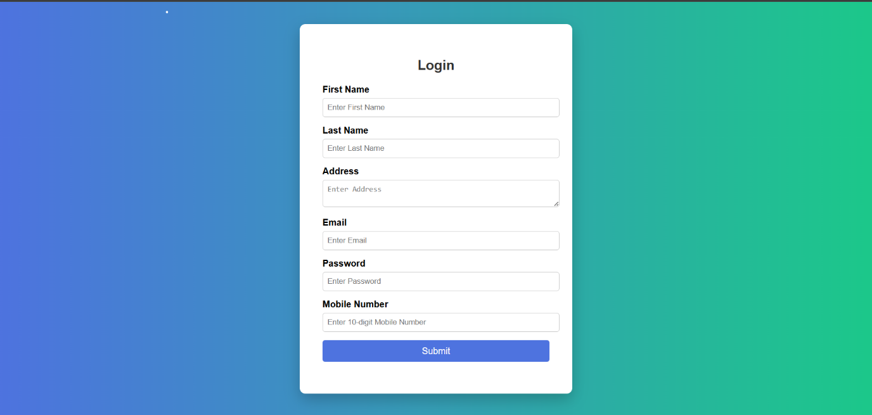

RESULT:
HTML page with Form is created and is validated using Javascript

